**TEST CASE – NOTES SHARING SYSTEM**

**USER REGISTRATION**:

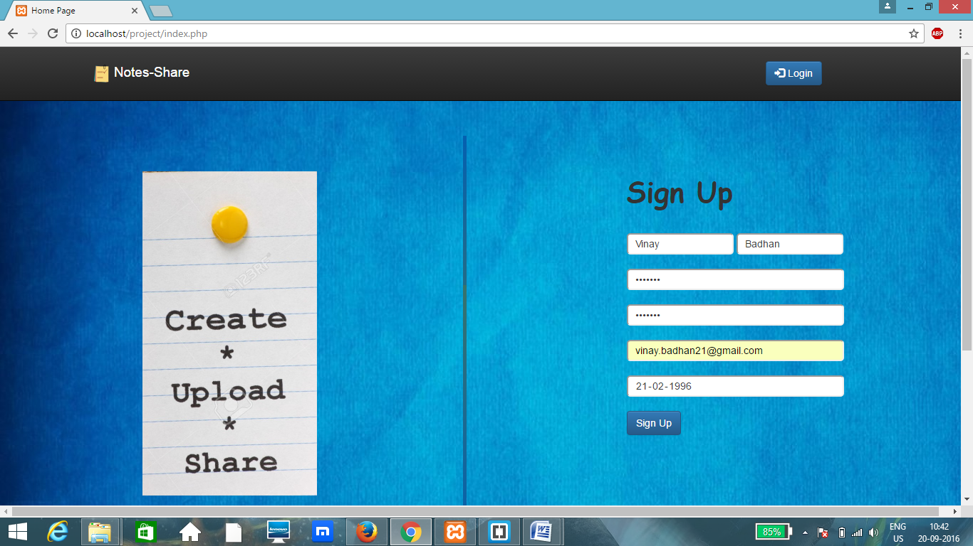

User entering data in the form present on the homepage: index.php

Once the entered data is validated, it is stored in database and the user is registered.

**USER LOGIN**:

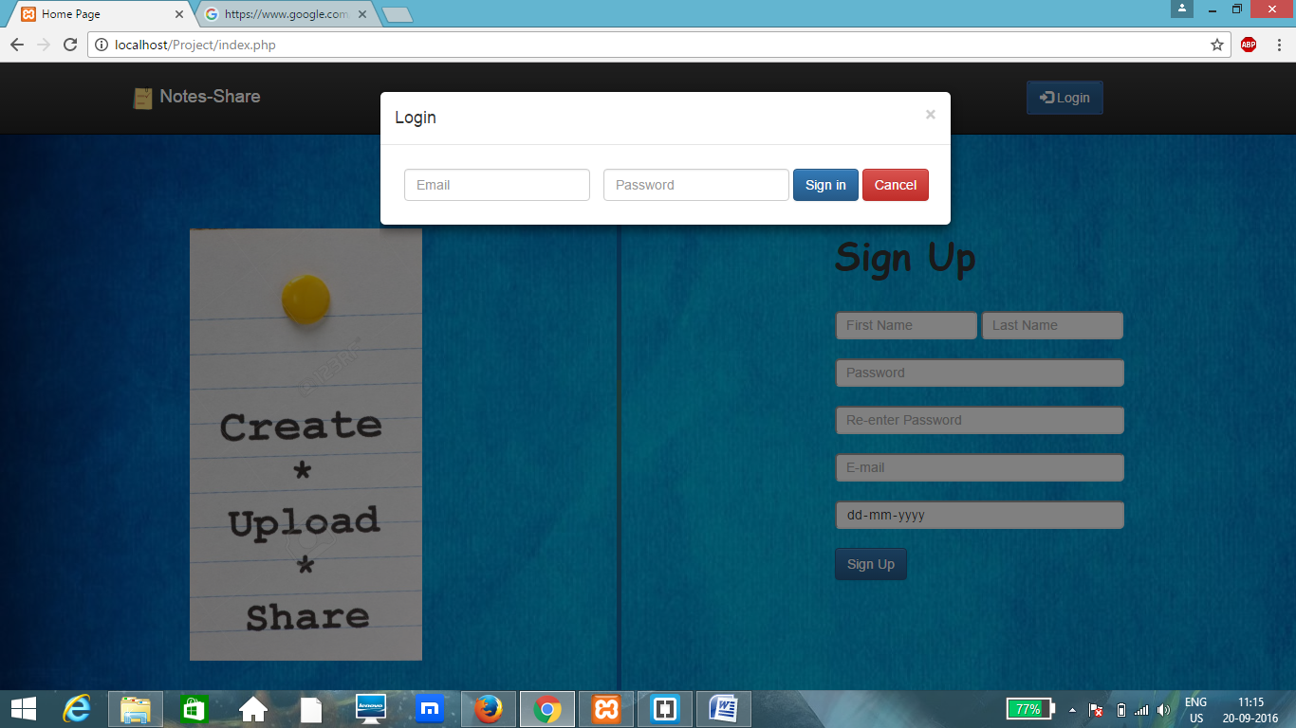

Once the user has logged in then he/she can edit the profile. Also uploading and downloading of pages can be done directly from the page. Also the user can choose a particular subject and choose the notes as per requirement.

**USER DOES NOT ENTER EMAIL AND PASSWORD**

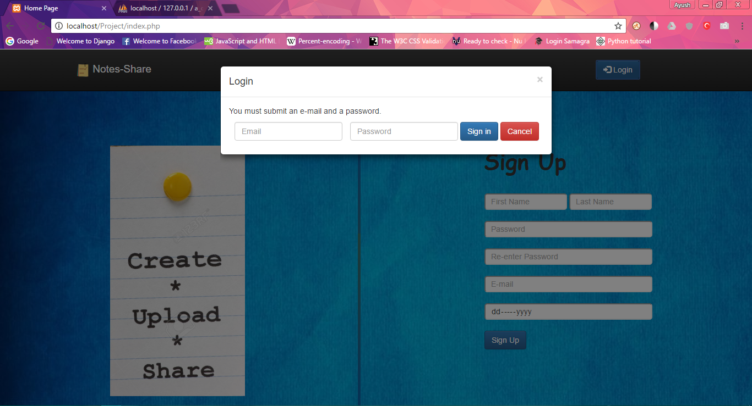

**PROFILE PAGE**:

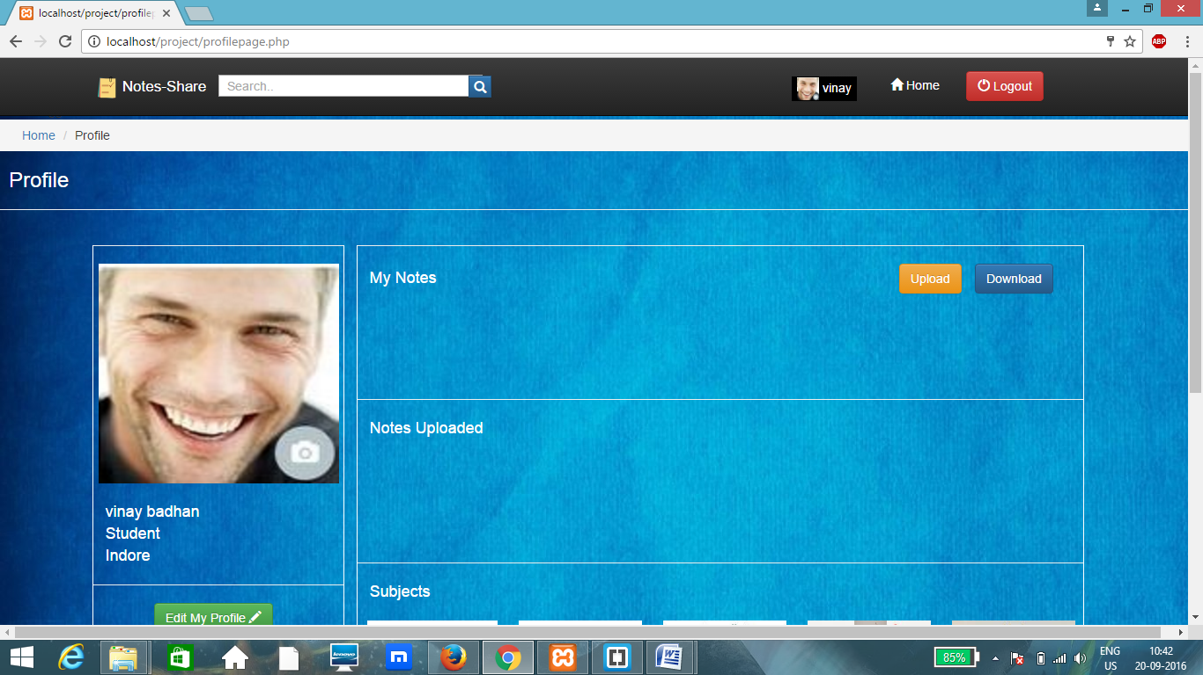

**EDIT PROFILE**:

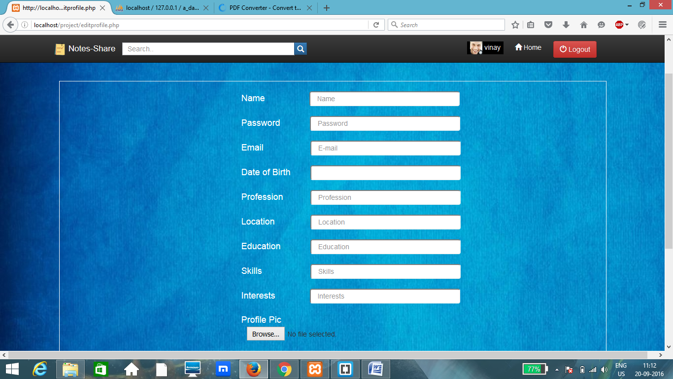

User can change the fields of their profile.

**LOGOUT**:

Users can logout of their account from any webpage.